🚀 What is an Azure VM Disk?
An Azure VM disk is virtual storage attached to a Virtual Machine.
It behaves like a physical HDD/SSD for OS or data storage.
You can attach:
- OS Disk (contains OS)
- Data Disk
- Temporary Disk (local SSD, not permanent)

🧩 Types of Azure VM Disks
Azure provides 5 main disk types:

1️⃣ Standard HDD
- Uses Hard Disk Drive technology.
- Lowest performance and cheapest.
- Best for:
  - Backup
  - Archival data
  - Low-traffic workloads
Performance:
- IOPS: Low
- Throughput: Low

2️⃣ Standard SSD
- Uses basic SSD technology.
- Better performance than HDD.
- Good for:
  - Web servers
  - Small to medium workloads
Performance:
- Medium IOPS
- Medium throughput

3️⃣ Premium SSD
- High-performance SSD backed by Azure Premium Storage.
- Ideal for:
  - Production workloads
  - Databases
  - Enterprise apps
Performance:
- High IOPS
- High throughput

4️⃣ Premium SSD v2
- Newer generation of SSD.
- Lower latency & higher performance than normal Premium SSD.
- Good for:
  - Transaction-heavy workloads
  - High-performance apps
Performance:
- Very high IOPS
- Very high throughput

5️⃣ Ultra Disk
- Fastest disk in Azure.
- Designed for:
  - Databases (Oracle, SQL, Mongo)
  - Large-scale transaction systems
  - Real-time analytics
Performance:
- Ultra high IOPS
- Ultra high throughput
- Very low latency

⚡ Key Performance Concepts
To understand disk performance, learn these two terms:

📌 1. IOPS (Input/Output Operations Per Second)
IOPS = how many read/write operations the disk can perform in one second.
Example:
- Standard HDD: Low IOPS (like 500–2,000)
- Premium SSD: High IOPS (up to thousands)
- Ultra Disk: Very high IOPS (up to 160,000+)
Higher IOPS = faster small reads/writes.

📌 2. Throughput (MB/s)
Throughput = how much data (in MB/sec) can be transferred per second.
Think:
- IOPS = number of operations
- Throughput = amount of data
Example:
- HDD: tens of MB/s
- Premium SSD: hundreds of MB/s
- Ultra Disk: thousands of MB/s
Higher throughput = faster large file read/write.

🔥 How Data is Fetched When a User Reads From Azure VM Disk
When a user or application tries to fetch data:
✔ Step 1: User/Program requests data
(e.g., reading a file or database block)
✔ Step 2: OS checks RAM (cache)
- If data is already in RAM → returned immediately → fast
✔ Step 3: If data is NOT in RAM → DISK READ occurs
- OS asks Azure disk to provide the data
- Disk performance depends on:
  - Disk type (HDD, SSD, Ultra)
  - IOPS
  - Throughput
✔ Step 4: Disk sends the data → OS loads it into RAM
- CPU can only access RAM, not disk directly
✔ Step 5: Data returned from RAM → CPU → User/App

🧠 Important!
❌ User/program cannot directly read from disk
✔ Data must go Disk → RAM → CPU → User
This happens for all Azure disk types.
2)the default vm size for linux is 30 and for window is 127
3)add extra disk to vm:- go to the vm-in left side-settings-disk-create and attach new disk and apply.after that log-in to the window server go to the server manager-in left side u will see file and storage services-disk-there u will see new disk that we just added-right click and initialize-yes-again right click-new volume-next-next-next-give label-next-create. Now go to the file explorer and see that there is new disk.

✅ PART 2 — Linux VM Steps (Inside OS)
Login to your Linux VM using SSH.

1️⃣ Check new disk
Run:
lsblk
You will see a new disk like:
sdc 10G
If old disk was /dev/sda, your new one is usually /dev/sdc or /dev/sdb.

2️⃣ Create a partition on the new disk
Use fdisk:
sudo fdisk /dev/sdc
Then inside fdisk menu enter:
- n → new partition
- p → primary
- 1 → partition number
- Press Enter for default first sector
- Press Enter for default last sector
- w → write
Partition created → /dev/sdc1

3️⃣ Format the disk (EXT4 filesystem)
sudo mkfs.ext4 /dev/sdc1

4️⃣ Create a mount directory
Example:
sudo mkdir /data

5️⃣ Mount the disk
sudo mount /dev/sdc1 /data
Now run:
df -h
You will see /data mounted.

6️⃣ Make mount permanent (IMPORTANT)
So it mounts even after reboot.
Edit fstab:
sudo nano /etc/fstab
Add line at bottom:
/dev/sdc1 /data ext4 defaults 0 0
Save → exit.

📌 Done! Your new disk is ready.
You can store files in:
/data

⭐ Summary (Very Simple Version)
Windows way: initialize → new volume → give drive letter.
Linux way:
lsblk → fdisk → mkfs.ext4 → mkdir /data → mount → update fstab.

4)stop,shutdown,restart:-
🔵 1. Restart VM (Inside Azure Portal or OS Restart)
When you click Restart:
✔ What happens?
- VM OS restarts (like rebooting a physical computer)
- VM stays in the Running state
- CPU, RAM, and compute resources remain allocated
- Public IP (if static) stays
- Private IP stays
- All disks remain attached
- Billing for VM compute continues
❌ What does NOT happen?
- VM is not deallocated
- You still pay for compute + disk
- Data is not lost
➡️ Restart = Reboot only, nothing else.

🟢 2. Shutdown the VM from inside the OS
Example:
You click Shut down inside Windows/Linux VM.
✔ What happens?
- OS powers off
- Azure does NOT deallocate the VM
- VM state becomes Stopped (Not Deallocated)
- CPU and RAM are still reserved
- Private IP is kept
- Public IP also remains assigned
💰 Billing?
- You still pay for compute + disk
Because Azure has kept the hardware reserved.
❗Important:
Shutdown from inside OS ≠ Stop VM
➡️ Shutdown = VM off but still costing money.

🔴 3. Stop VM (Deallocate) from Azure Portal
When you click Stop in Azure Portal or use CLI/PowerShell:
✔ What happens?
- VM is powered off
- VM is deallocated
- CPU and RAM are released back to Azure pool
- State becomes Stopped (Deallocated)
- OS and data disks remain safe
- Public IP is:
  - Lost if dynamic
  - Retained if static
💰 Billing?
- Compute cost stops
- You only pay for disks
(OS disk + data disks + snapshots)
➡️ Stop = VM off + no compute billing.

If u stored your data in temporary disk and stop the disk then data will get lost.
5)snapshot of disk.

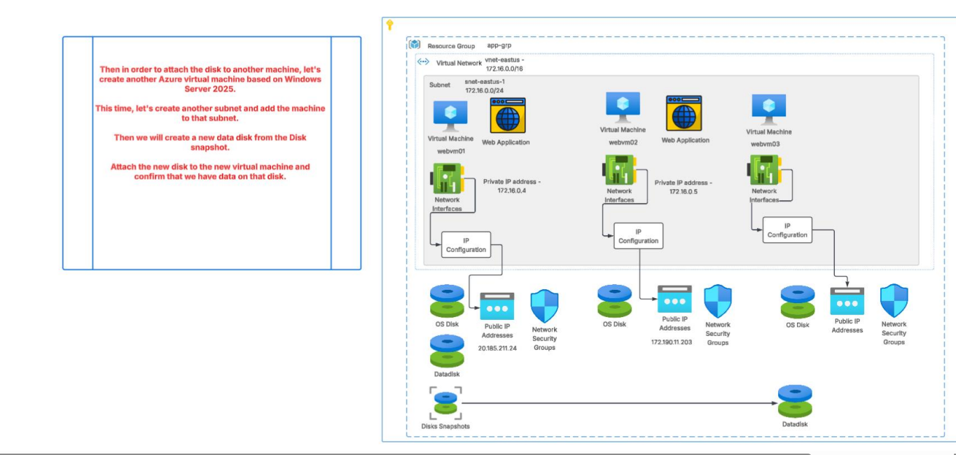

✅ Correct Step-by-Step Flow to Create Snapshot → Create Disk → Create New VM
1. Go to the Resource Group
✔ Yes.
2. Open the VM’s OS Disk
✔ Correct.
3. Click “Create Snapshot” (at the top)
✔ Correct.
4. Choose the same Resource Group
✔ Optional, but recommended for organization.
5. Select Snapshot Type → Full Snapshot
✔ Yes (Full snapshot costs more but is simplest).
Incremental snapshot is cheaper but optional.
6. After snapshot is created → click the snapshot
✔ Correct.
7. Click “Create Disk” (top menu)
✔ Yes — this is required to convert snapshot → managed disk.
8. Add Resource Group → Create Disk
✔ Correct.
9. Create a new VM
✔ Yes.
10. In the VM creation wizard → go to “Disks” section
✔ Correct.
11. Choose “Use an existing disk”
✔ Correct.
12. Select the disk you created from the snapshot
✔ Correct — this becomes your OS Disk for the new VM.

⭐ FINAL RESULT
✔ New VM created using the OS disk snapshot
✔ Snapshot → Managed Disk → VM = Correct process

🌕 1) Full Snapshot
A full snapshot takes a complete backup of the entire disk every time.

✔ Characteristics:
- Captures full copy of the disk (all blocks)
- Largest size (stores everything)
- Cost is high because full data is stored every time
- Slower to create
- Useful when you want a one-time complete backup

👍 When to use?
- Before major upgrade/migration
- When you want one clean copy of the entire disk
- Not good for daily backup (too expensive)

🌗 2) Incremental Snapshot
An incremental snapshot only stores the changes (delta) from the previous snapshot.

✔ Characteristics:
- Saves ONLY changed blocks
- Very cheap (pays only for changed data)
- Fastest snapshot type
- Very storage efficient
- Azure stores them in a chain
- You can restore VM from ANY snapshot in the chain

👍 When to use?
- Daily snapshots
- Frequent backups
- Cost-sensitive environments
- Production servers

6)server side encryption:-
🔐 What is Server-Side Encryption (SSE) in Azure Disks?
Server-Side Encryption (SSE) means that Azure automatically encrypts your VM disks at the storage level before saving the data to Azure Storage, and automatically decrypts it when the data is read.
So the encryption and decryption happen on Azure’s servers, not on your VM.
➡️ You do NOT need to write any code or install anything.
➡️ It is always enabled for managed disks.

⭐ Simple Definition
Server-Side Encryption = Azure encrypts your disk data automatically before storing it, and decrypts it automatically when you access it.

🧩 What gets encrypted?
SSE encrypts:
- OS Disk
- Data Disks
- Snapshots
- Images
- Disk backups
- Cache data
Everything stored in Azure Storage is encrypted.

🛡 What keys are used for encryption?
Azure offers two types of keys:
1️⃣ Platform-Managed Keys (PMK) – Default
- Encryption keys are managed by Azure
- No user action needed
- Enabled automatically
- No extra cost
✔ Simple
✔ Secure
✔ Recommended for most workloads
2️⃣ Customer-Managed Keys (CMK)
- You store your own encryption keys in Azure Key Vault
- You control key rotation
- Used for high-security or compliance
CMK is optional, but required for:
- Banking
- Government
- Sensitive data

7)lets create the customer managed keys for server side encryption using azure key vault.
WHEN U GO TO THE DISK-SETTING-ENCRYPTION- UOU WILL SEE THAT PLATFORM-MANAGED-KEY ENCRYPTION IS ENABLED BY DEFAULT.

🔐 Azure Key Vault (Short Information)
Azure Key Vault is a cloud service that helps you securely store and manage:
✅ Keys
Used for encryption/decryption (ex: disk encryption keys, application keys).
✅ Secrets
Sensitive data like passwords, connection strings, API keys.
✅ Certificates
SSL/TLS certificates for securing websites and applications.

Go to the key vault. And create
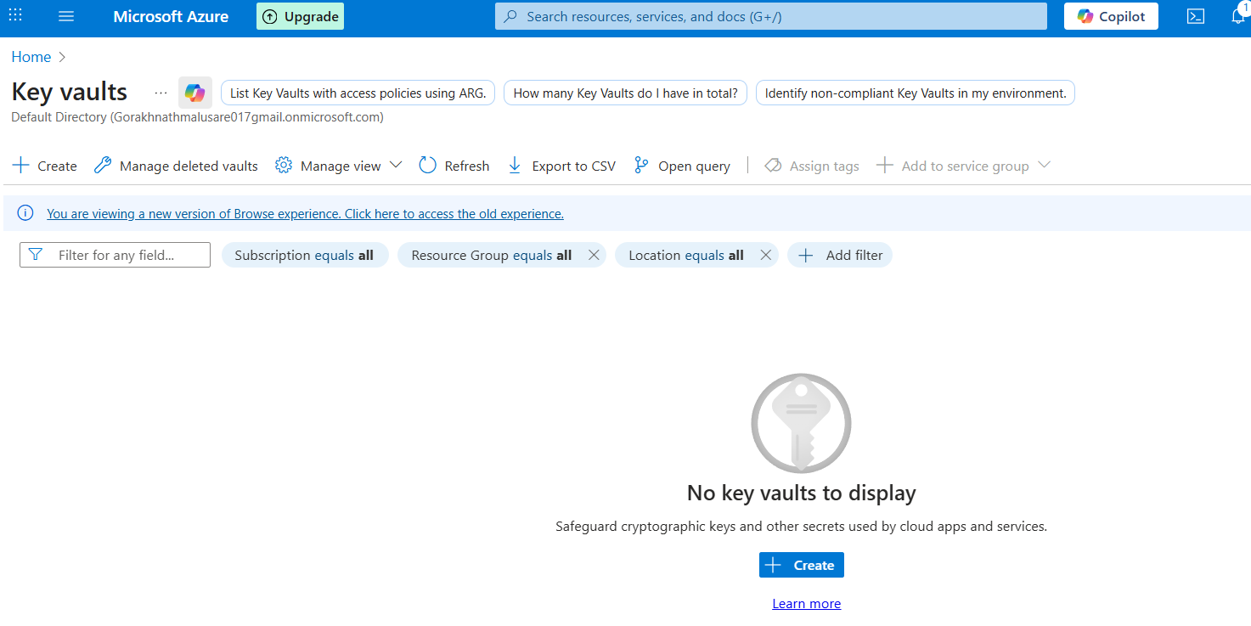

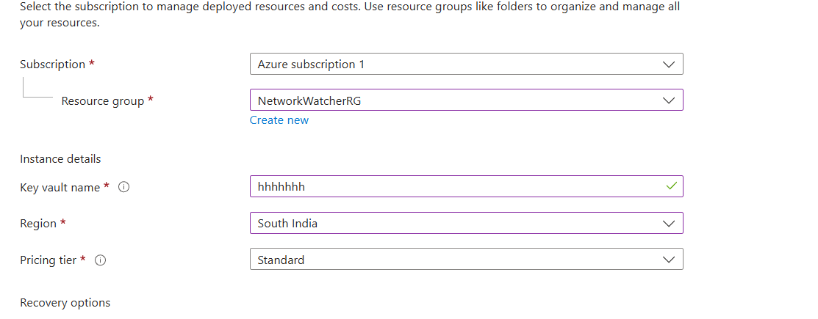

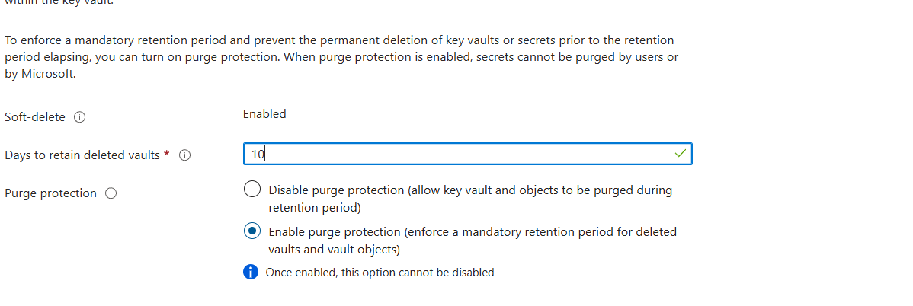
If anyone delete the key so it will go to soft delete retention period for specified day that u specificed.

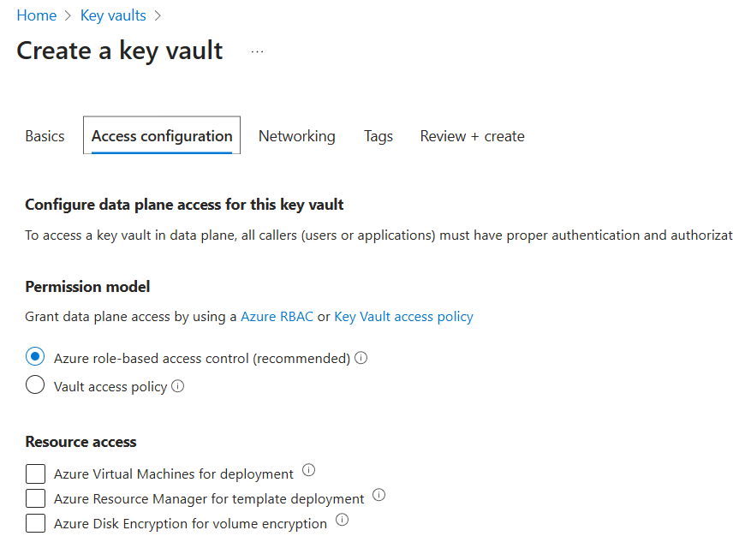
After creating the key vault -go to that vault if u don’t have permission over there u can see left side iam go to that-create role assessment-add role key vault administrator-and assign to u.
after that u can generate the key.
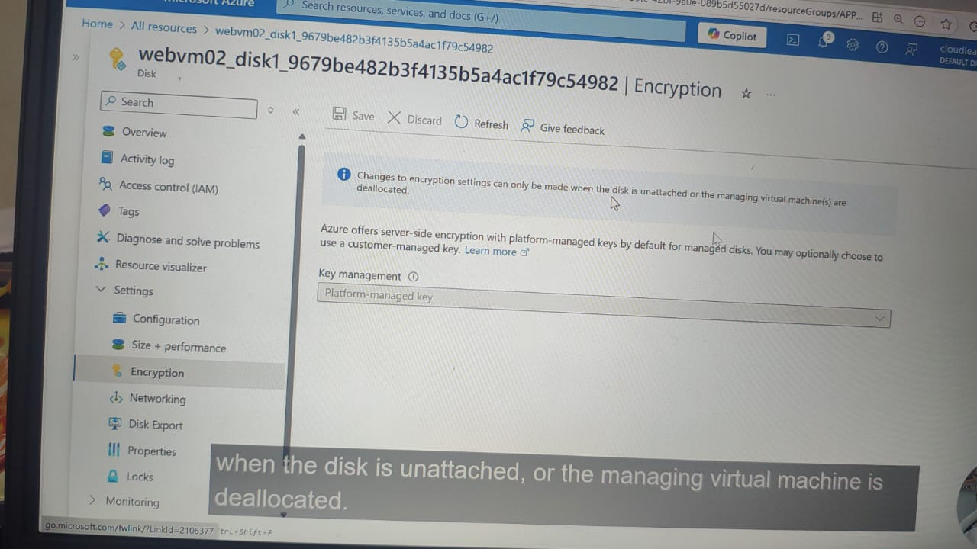
After that stop the vm.
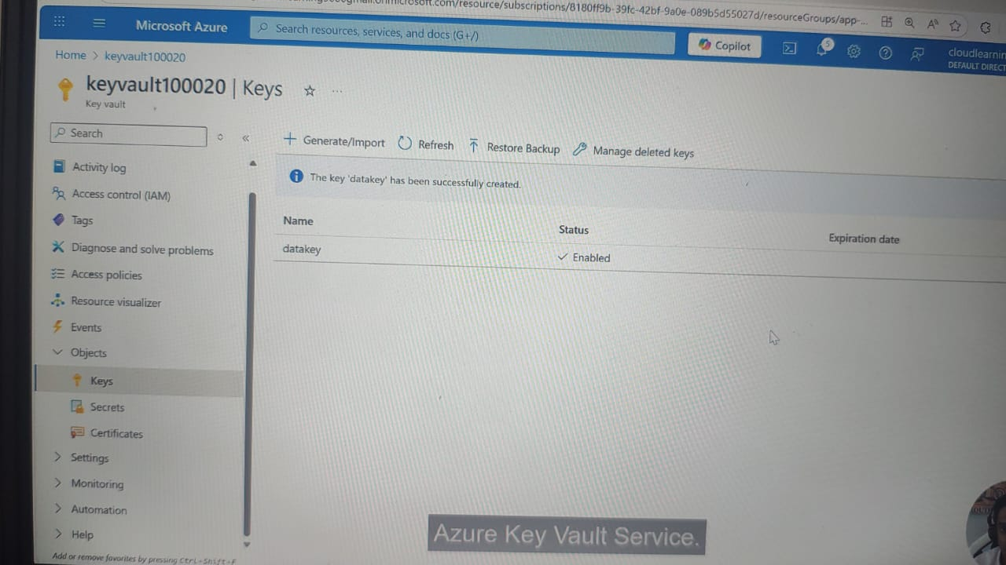

Now we have to create something known as disk encryption set,
That disc encryption disk is going to make use of our encryption key, after that we can change the disc setting to use that disc encryption set..

After that we create the encryption set in that we use key vault and after creating we go to tha disk-setting-encryption and add customer-managed-key : encryptionset

⭐ SUPER-SHORT INTERVIEW ANSWER
Server-Side Encryption (SSE):
“Azure encrypts disks automatically at the storage layer. No VM changes. Default and always on.”
Azure Disk Encryption (ADE):
“Disk is encrypted inside the VM using BitLocker (Windows). Uses Key Vault. Provides OS-level encryption.”
S

